FreelanceFinder: DiscoveringOpportunities, Unlocking Potential

**ProjectTitle:** FreelanceFinder: Discovering Opportunities, Unlocking Potential

**Team Information:**

**TeamID:** LTVIP2025TMID21224

**TeamSize:** 4

**TeamLeader:** Yarrapothu Eswar Manikanta Sai

**Teammembers:** Y Krishna Asin Thara, Yarlagadda Monika, Yannam Manasvi Neha Naidu

# Introduction:

Welcome to FreelanceFinder, your dedicated platform for exploring freelancing opportunities and unlockingyourfullpotentialinthedigitalmarketplace.Whetheryou'reabuddingfreelancerlookingfor your first project or a seasoned expert seeking new challenges, FreelanceFinder connects talent with demand. Our platform is designed with a user-centric approach to empower individuals and businesses through seamless connections and transparent workflows.

# Description:

FreelanceFinder isn't just a freelancing portal; it's a comprehensive ecosystem created to revolutionize thewayfreelancersandclientscollaborate.Theplatformoffersawidearrayofprofessionalopportunities acrosscategoriessuchaswebdevelopment,contentwriting,graphicdesign,marketing,datascience,and more.

Our intuitive interface ensures that users can easily create profiles, browse projects, submit proposals, and get hired quickly. With advanced search filters, recommendation algorithms, secure payment systems, and real-time communication tools, FreelanceFinder removes barriers and enhances productivity for both freelancers and clients.

Whetheryou'rebuildingyourportfolioorsourcingtoptalentforyourstartup,FreelanceFinderoffersthe resources, tools, and support you need to thrive.

# ScenarioBasedCaseStudy:

## MeetRiya,anaspiringgraphicdesigner.

Riyaisacreativegraduatewithaflairforvisualstorytellingbutlacksindustryconnectionstogetstarted.She signs up on FreelanceFinder, completes her profile, and uploads her portfolio.

* **UserRegistrationandAuthentication:**Riyaregistersontheplatform,verifiesheridentity,and sets up her professional profile.
* **ProjectBrowsing:**Sheexploresavailablegigsusingcategoryfiltersandtagstofinddesign- related projects.
* **SmartSuggestions:**Basedonherskillsandportfolio,FreelanceFinderrecommendsprojects aligned with her interests.
* **Proposal Submission:** She sends customized proposals and eventually lands her first freelance gig designing a logo for a startup.
* **SecurePayments:**Aftercompletingthetask,shereceivespaymentsecurelythrough FreelanceFinder's escrow-based payment system.
* **Rating&Review:**Riyaearnsa5-starratingandapositivereview,helpingherattractmore clients.

ThankstoFreelanceFinder,Riyabuildsasustainablefreelancecareerdoingwhatsheloves,without worrying about delayed payments or finding clients.

# TechnicalArchitecture:-

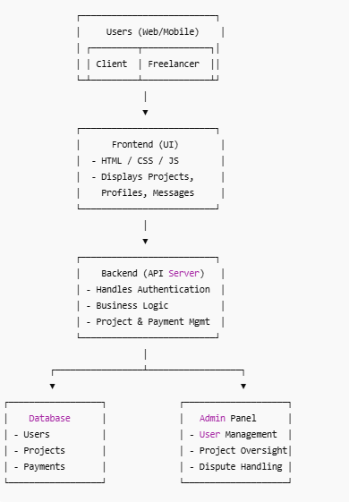

FreelanceFinder follows a modern web architecture based on the MERN stack (MongoDB, Express.js, React.js, Node.js).

* **Frontend:**BuiltusingReact.jsforadynamicandresponsiveuserinterface.
* **Backend:**Node.jsandExpress.jshandleAPIlogic,userauthentication,andjobmanagement.
* **Database:**MongoDBstoresuserdata,projectlistings,messages,andreviews.
* **Communication:** RESTful APIs connect frontend and backend, with WebSocket used for real- time messaging.
* **Security:**JWT-basedauthentication,encryptedpasswordstorage,andsecurefileuploads.

# ER-Diagram:

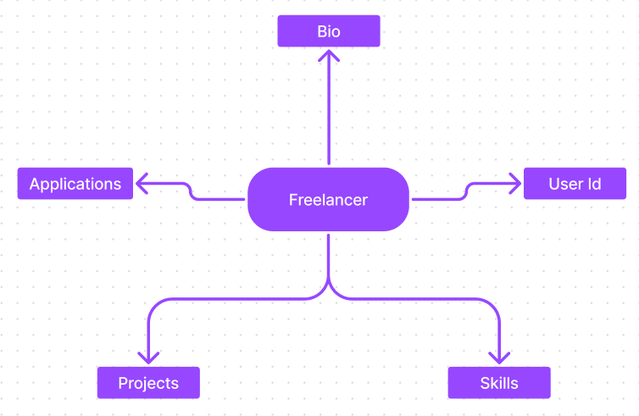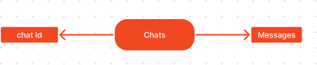

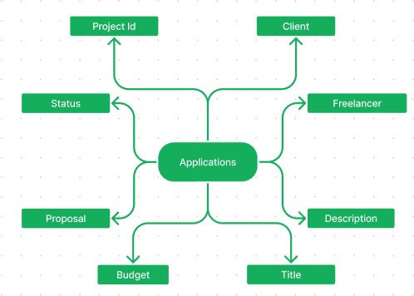

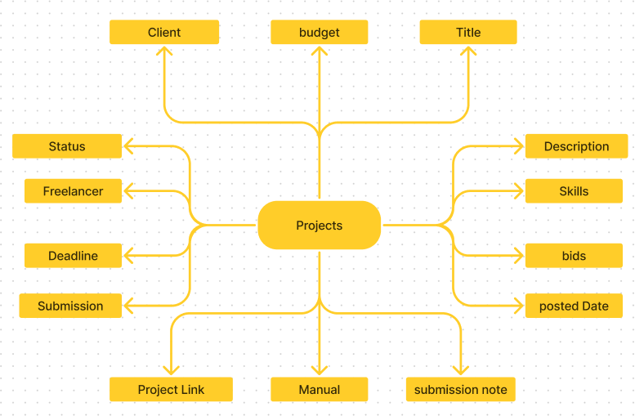

## ER-DiagramOverview:

* Users
* Freelancer
* Chats
* Applications
* Projects

# KeyFeatures:

* **ProfileManagement:**Freelancersandclientscancustomizeandmanagetheirprofiles**.**
* **ProjectListings:**Clientspostprojectswithdetailedrequirements,budgets,anddeadlines.
* **SmartMatching:**Recommendationenginematchesfreelancerstorelevantjobs.
* **SecurePayments:**Escrow-basedpaymentprotectionensuresfreelancersgetpaidandclientsget quality work.
* **MessagingSystem:**Real-timechatallowssmoothcommunicationandcollaboration.
* **DashboardAnalytics:**Clientsandfreelancersgetinsightsintoearnings,performance,and proposals.
* **AdminPanel:**Allowsplatformmoderatorstomanageusers,content,disputes,andreports.

**PRE REQUISITES:**

Herearethekeyprerequisitesfordevelopingafull-stackapplicationusingExpressJs,MongoDB, React.js:

# Node.jsandnpm:

Node.js is apowerfulJavaScript runtimeenvironment that allows you to runJavaScript codeon the server-side. It provides a scalable and efficient platform for building network applications.

InstallNode.jsandnpmonyourdevelopmentmachine,astheyarerequiredtorunJavaScripton the server-side.

Download:https://nodejs.org/en/download/

Installationinstructions:<https://nodejs.org/en/download/package-manager/>

**Express.js**:

Express.js is a fast and minimalist web application framework for Node.js. It simplifies the processofcreatingrobustAPIsandwebapplications,offering featureslikerouting,middleware support, and modular architecture.

Install Express.js, a web application framework for Node.js, which handles server-side routing, middleware, and API development.

Installation:Openyourcommandpromptorterminalandrunthefollowingcommand:

**npminstallexpress MongoDB:**

MongoDB is a flexible and scalable NoSQL database that stores data in a JSON-like format. It provideshighperformance,horizontalscalability,andseamlessintegrationwithNode.js,making it ideal for handling large amounts of structured and unstructured data.

Set up a MongoDB database to store your application's data.Download: https://[www.mongodb.com/try/download/community](http://www.mongodb.com/try/download/community) Installationinstructions:<https://docs.mongodb.com/manual/installation/>

**React.js**:

React.jsisapopularJavaScriptlibraryforbuildinguserinterfaces.Itenablesdeveloperstocreate interactive and reusable UI components, making it easier to build dynamic and responsive web applications.

InstallReact.js,aJavaScriptlibraryforbuildinguserinterfaces.

Followtheinstallationguide:<https://reactjs.org/docs/create-a-new-react-app.html>

**HTML,CSS,andJavaScript:**BasicknowledgeofHTMLforcreatingthestructureofyourapp, CSS for styling, and JavaScript for client-side interactivity is essential.

**Database Connectivity:** Use a MongoDB driver or an Object-Document Mapping (ODM) librarylikeMongoosetoconnectyourExpressJsserverwiththeMongoDBdatabaseandperform CRUD (Create, Read, Update, Delete) operations.

**Front-endFramework:**UtilizeReactJstobuildtheuser-facingpartoftheapplication,including entering booking room, status of the booking, and user interfaces for the admin dashboard. For making better UI we have also used some libraries like material UI and bootstrap.

**Version Control:** Use Git for version control, enabling collaboration and tracking changes throughout the development process. Platforms like GitHub or Bitbucket can host your repository.

Git:Downloadandinstallationinstructionscanbefoundat:https://git-scm.com/downloads

**Development Environment:** Choose a code editor or Integrated Development Environment (IDE) that suits your preferences, such as Visual Studio Code, Sublime Text, or WebStorm.

* **VisualStudioCode:**Downloadfrom<https://code.visualstudio.com/download>

**InstallDependencies:**

* Navigateintotheclonedrepositorydirectory:

cdfreelancer-app-MERN

* Installtherequireddependenciesbyrunningthefollowingcommands: cd client

npminstall

../cdserver npminstall

StarttheDevelopmentServer:

* Tostartthedevelopmentserver,executethefollowingcommand:

npm start

* Thisappwillbeaccessibleat[http://localhost:3000](http://localhost:3000/)

You have successfully installed and set up the SB application on your local machine. You can now proceed with further customization, development, and testing as needed.

# RolesandResponsibility:

**FreelancerResponsibilities:**

* Project Submission: Freelancers are responsible for submitting completed and high-quality work for the assigned projects through the platform.
* Compliance:Ensurethatthesubmittedworkadherestoclientrequirements,industrystandards,and

anyspecificguidelinesoutlinedbytheplatform.

* EffectiveCommunication:Activelyengageincommunicationwithclients,promptlyrespondingto

messages,askingclarifyingquestions,andprovidingupdatesontheprojectprogress.

* TimeManagement:Managetimeeffectivelytomeetprojectdeadlinesanddeliverworkinatimely

manner.

* Professionalism:Conductoneselfprofessionallybymaintainingarespectfulandcooperativeattitude

withclientsandfellowfreelancers.

* QualityAssurance:Deliverworkthatisaccurate,well-executed,andfreefromerrorstomaintainclient satisfaction.

**ClientResponsibilities:**

* ClearProjectDescription:Provideadetailedandcomprehensiveprojectdescription,includingdeliverables, desired outcomes, and any specific requirements.
* TimelyCommunication:Respondpromptlytofreelancerinquiries,providingnecessaryinformation

andfeedbackinatimelymanner.

* PaymentObligations: Fulfilltheagreed-upon payment terms promptly and fairly uponsatisfactory completion of the project.
* FeedbackandEvaluation:Provideconstructivefeedbackandevaluatethefreelancer'sperformance,

helpingthemimproveandprovidingvaluableinsights.

**AdminResponsibilities:**

* + DataOversight:Asanadmin,oneofyourkeyresponsibilitiesistomonitorandensurethe integrity and security of all data on the platform
  + Policy Enforcement: Admins play a crucial role in enforcing platform policies, guidelines, andethical standards.
  + ConflictResolution:Intheeventofdisputesorissueswithinthecommunity,itistheadmin's responsibility to address them promptly and impartially
  + User Support and Communication: Admins should provide support and guidance to users on the platform
  + PlatformMaintenanceandImprovement:Adminsareresponsiblefortheoverallmaintenanceand improvement of the research platform.

# PROJECTFLOW:-

Beforestartingtoworkonthisproject,let’sseethedemo.

Demolink:-

<https://drive.google.com/file/d/18-gnCVAZdojBhl7QM0_yShH1JL5A6v32/view?usp=drive_link>

Use the code in:-<https://drive.google.com/drive/folders/1gSc8RWmM7yqdvYh525n5DoLjZxS_N-F4>or follow the videos below for better understanding.

# Milestone1:ProjectSetupandConfiguration:

1. **Installrequiredtoolsandsoftware:**
   * Node.js.
   * MongoDB.
   * Create-react-app.

# Createprojectfoldersandfiles:

* + Clientfolders.
  + Serverfolders.

# InstallPackages:

**FrontendnpmPackages**

* + Node
  + React
  + Bootstrap.

# BackendnpmPackages

* + Express.
  + Mongoose.
  + Body-parser
  + Cors.

# Milestone2:BackendDevelopment:

* + **Setupexpressserver**
    1. Createindex.jsfileintheserver(backendfolder).
    2. Createa.envfileanddefineportnumbertoaccessitglobally.
    3. Configuretheserverbyaddingcors,body-parser.

# UserAuthentication:

* Createroutesandmiddlewareforuserregistration,login,andlogout.
* Setupauthenticationmiddlewaretoprotectroutesthatrequireuserauthentication.

# DefineAPIRoutes:

* Create separate route files for different API functionalities such as users orders, and authentication.
* Definethenecessaryroutesforlistingproducts,handlinguserregistration andlogin,managing orders, etc.
* Implement route handlers using Express.js to handle requests and interact with thedatabase.

# ImplementDataModels:

* DefineMongooseschemasforthedifferentdataentitieslikeproducts,users,and orders.
* CreatecorrespondingMongoosemodelstointeractwiththeMongoDBdatabase.
* ImplementCRUDoperations(Create,Read,Update,Delete)foreachmodelto perform database operations.

# UserAuthentication:

* Createroutesandmiddlewareforuserregistration,login,andlogout.
* Setupauthenticationmiddlewaretoprotectroutesthatrequireuserauthentication.

# ErrorHandling:

* Implementerrorhandlingmiddlewaretocatchandhandleanyerrorsthatoccurduring the API requests.
* ReturnappropriateerrorresponseswithrelevanterrormessagesandHTTPstatuscodes.

# Milestone3:Database:

1. **ConfigureMongoDB:**
   * InstallMongoose.
   * Createdatabaseconnection.
   * CreateSchemas&Models.

# Connectdatabasetobackend:

Now, make sure the database is connected before performing any of the actions through thebackend. The connection code looks similar to the one provided below.

constmongoose=require("mongoose");

constdb= 'mongodb://127.0.0.1:27017/grocery'

//ConnecttoMongoDBusingtheconnection string

mongoose.connect(db, { useNewUrlParser: true, useUnifiedTopology:true,

}).then(() =>{ console.log(`Connectionsuccessful`);

}).catch((e)=>{

console.log(`Noconnection:${e}`);

});

# ConfigureSchema:

Firstly, configure the Schemas for MongoDB database, to store the data in such pattern. Use the data from the ER diagrams to create the schemas.

Theschemas arelookslikeforthe Application.

importmongoose,{Schema,mongo}from "mongoose";

constuserSchema=*mongoose*.Schema({ username: {

type:*String*, require:true

},

email: {

type:*String*, require:true, unique: true

},

password: { type:*String*, require:true

},

usertype:{type:*String*, require:true

}

})

constfreelancerSchema=*mongoose*.Schema({ userId: *String*,

skills:{

type:*Array*, default:[]

},

description: { type:*String*, default: ""

},

currentProjects:{ type: *Array*, default:[]

},

completedProjects:{ type: Array, default:[]

},

applications:{ type:Array, default:[]

},

funds:{

type:Number, default:0

},

})

constprojectSchema=mongoose.Schema({ clientId:String,

clientName:String,

clientEmail:String, title:String, description:String, budget: Number, skills: Array,

bids:Array, bidAmounts:Array, postedDate:String, status: {

type:String,default:"Available"

},

freelancerId:String, freelancerName:String, deadline: String, submission: {

type:Boolean, default:false

},

submissionAccepted:{ type: Boolean, default:false

},

projectLink: { type:String, default: ""

},

manulaLink:{ type:String, default: ""

},

submissionDescription:{ type:String,

default: ""

},

})

constapplicationSchema=mongoose.Schema({

projectId:String, clientId:String, clientName:String, clientEmail:String, freelancerId:String, freelancerName:String, freelancerEmail:String, freelancerSkills:Array, title: *String*,description: *String*, budget: *Number*, requiredSkills: *Array*, proposal: *String*, bidAmount: *Number*,

estimatedTime:*Number*, status: {

type: *String*, default:"Pending"

}

})

constchatSchema= *mongoose*.Schema({

_id:{

type:*String*, require:true

},

messages: { type:*Array*

}

})

exportconstUser=*mongoose*.model('users',userSchema);

exportconstFreelancer=*mongoose*.model('freelancer',freelancerSchema); export const Project = *mongoose*.model('projects', projectSchema);

exportconstApplication=*mongoose*.model('applications',applicationSchema); export const Chat = *mongoose*.model('chats', chatSchema);

# Milestone4:FrontendDevelopment:

1. **SetupReactApplication:**
   * CreateReactapplication.
   * ConfigureRouting.
   * Installrequiredlibraries.

# DesignUIcomponents:

* + Create Components.
  + Implementlayoutandstyling.
  + Addnavigation.

# Implementfrontendlogic:

* + IntegrationwithAPIendpoints.
  + Implementdatabinding.

# Milestone5:ProjectImplementation:

Finally, after finishing coding the projects we run the whole project to test it’s working process and look for bugs. Now, let’s have a final look at the working of our Darshan Ease.

**Home Page:**

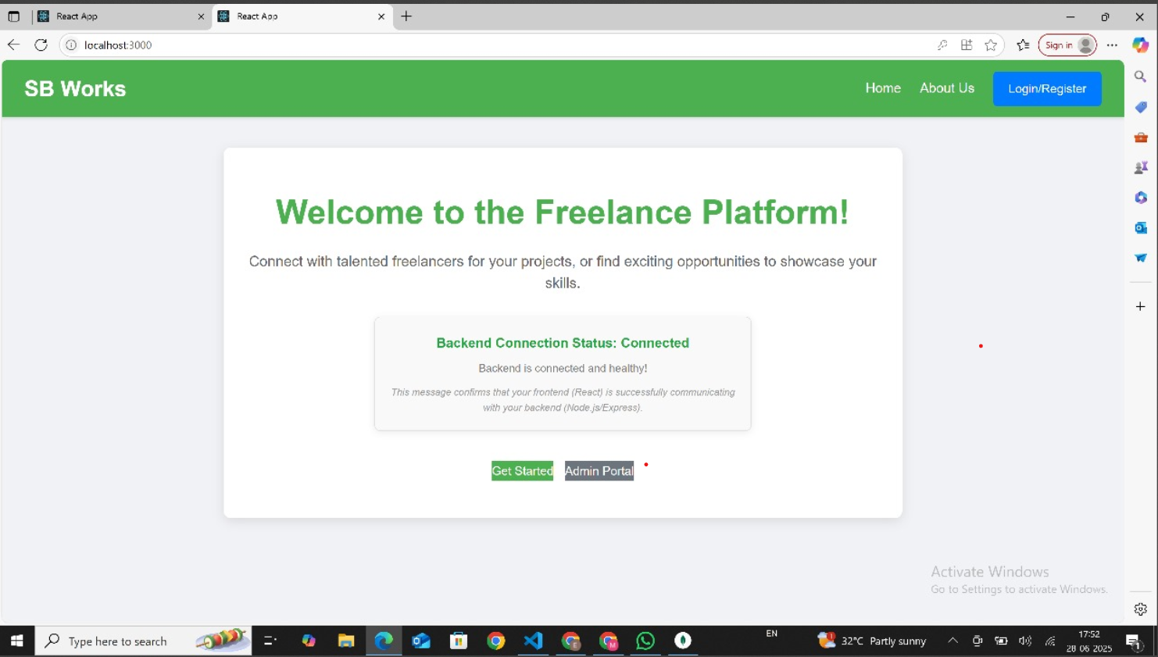

**About Us Page:**

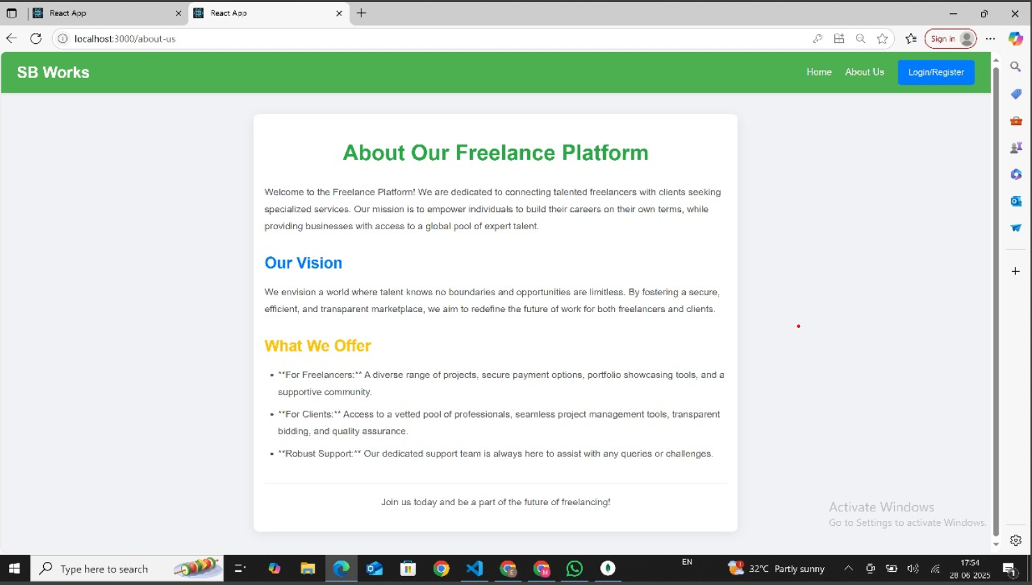

**Admin Login Page:**

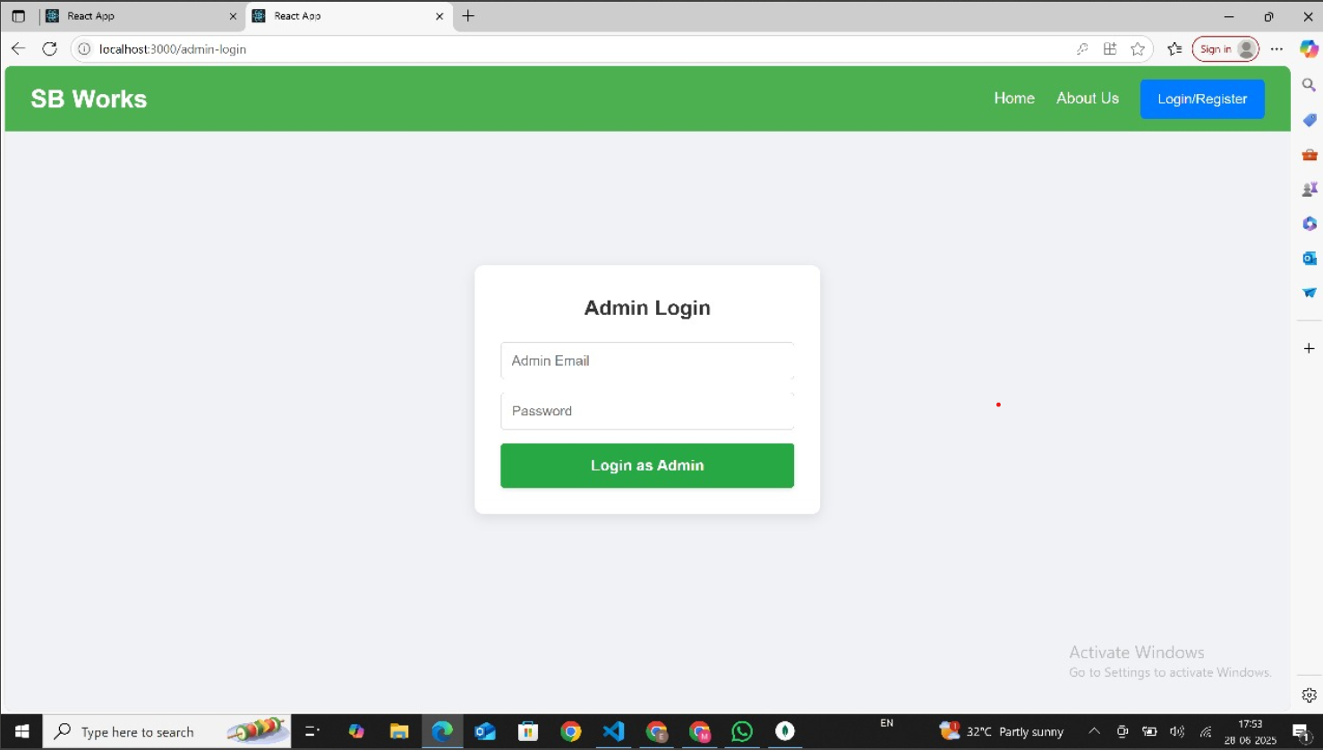

**Client / Freelancer Login Page:**

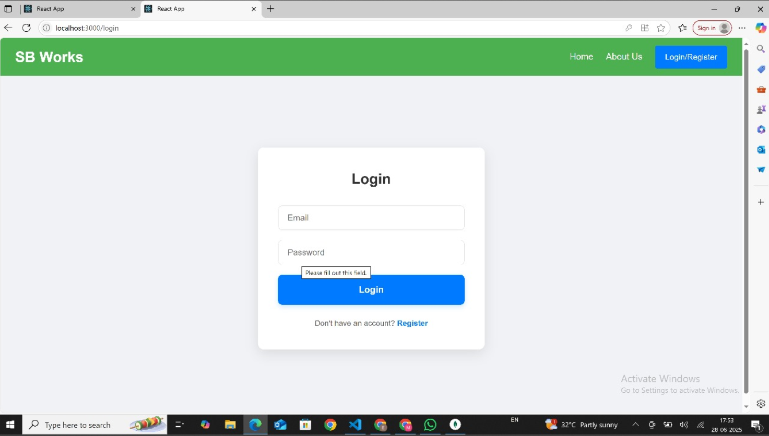

**Registration Page:**

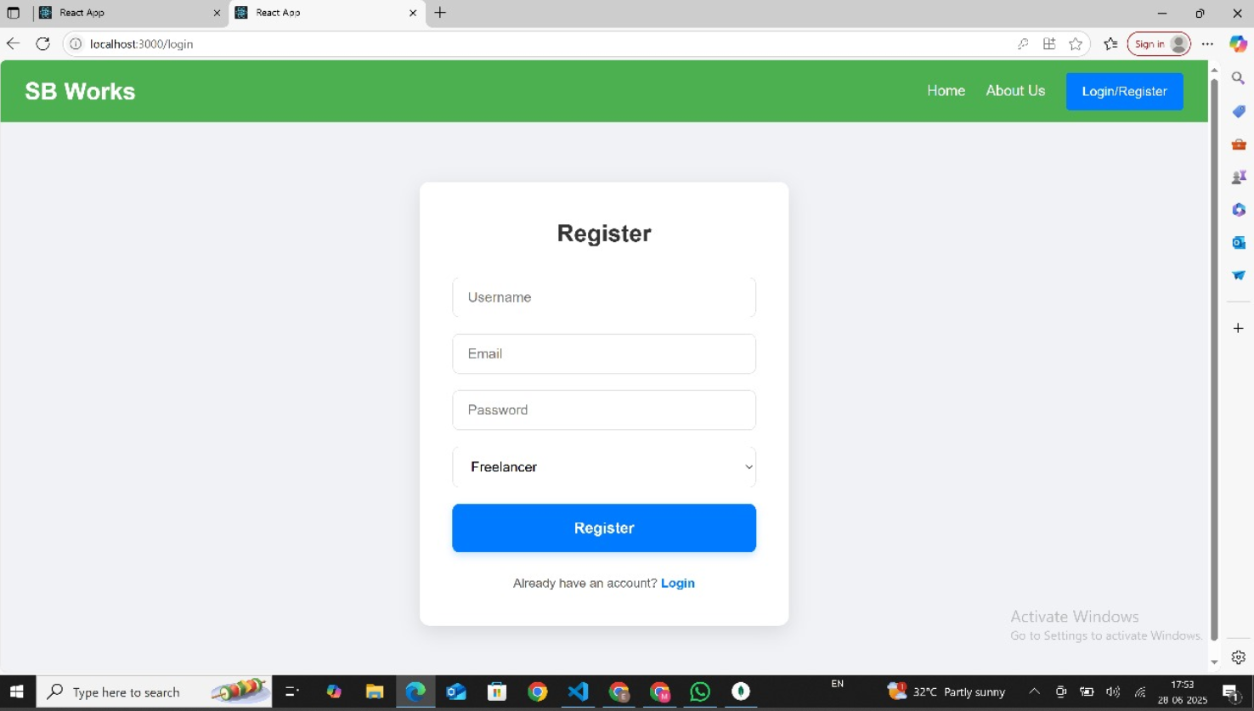

**Client Portal:**

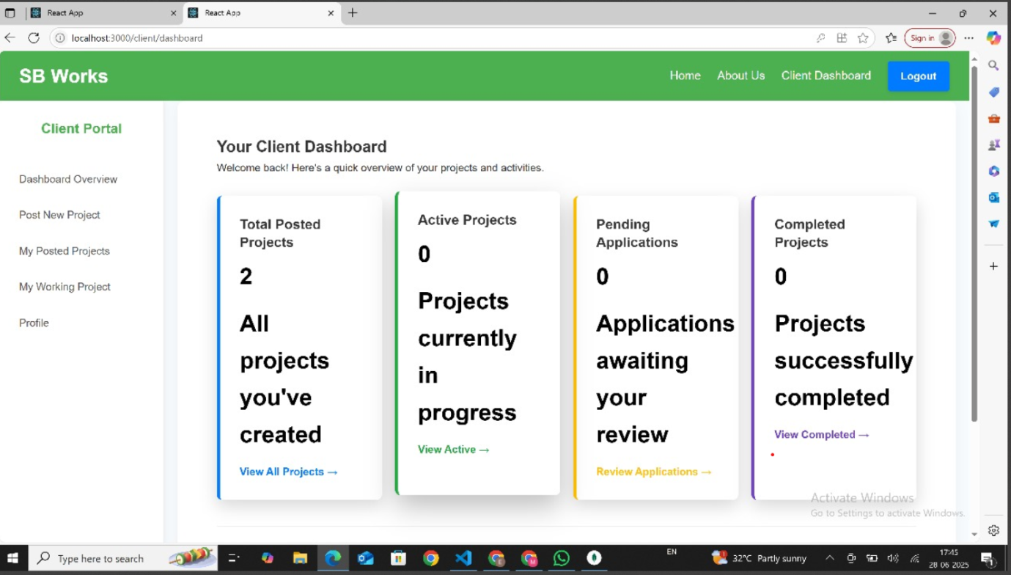

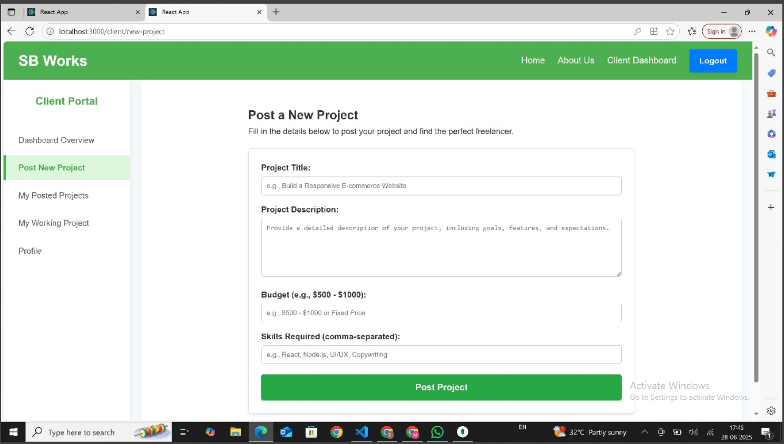

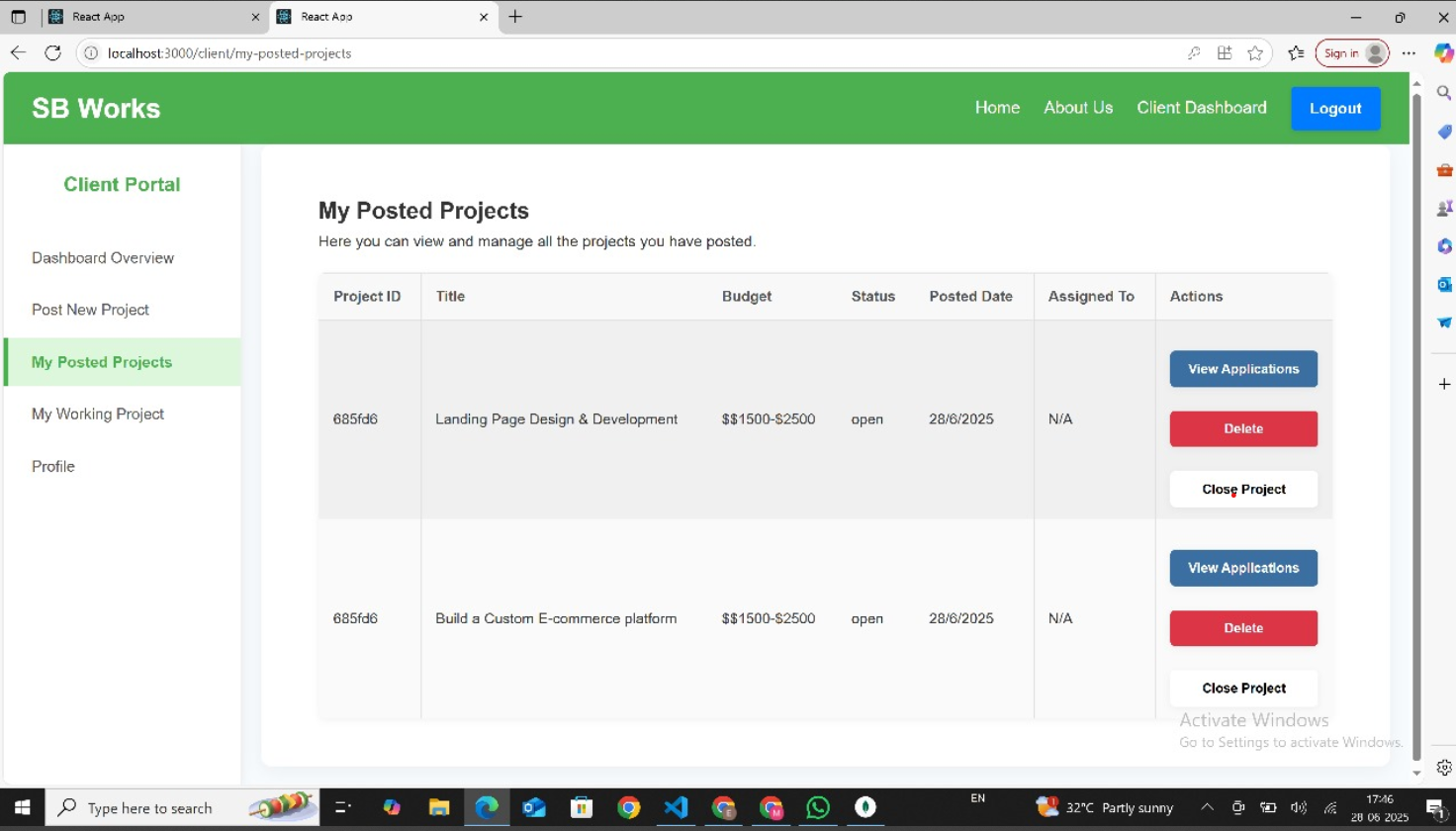

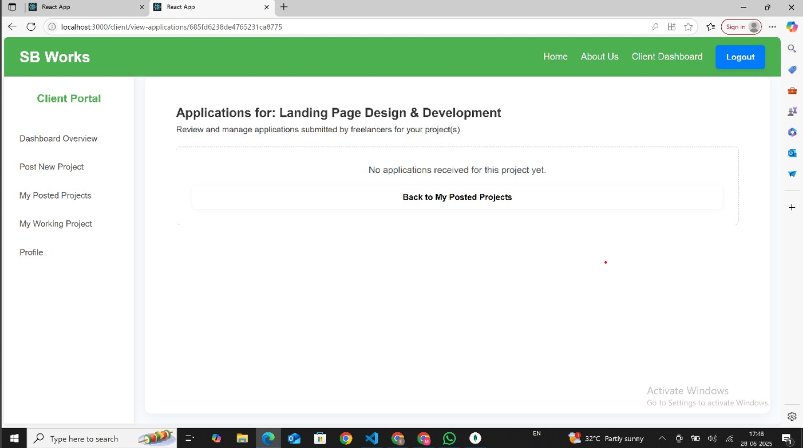

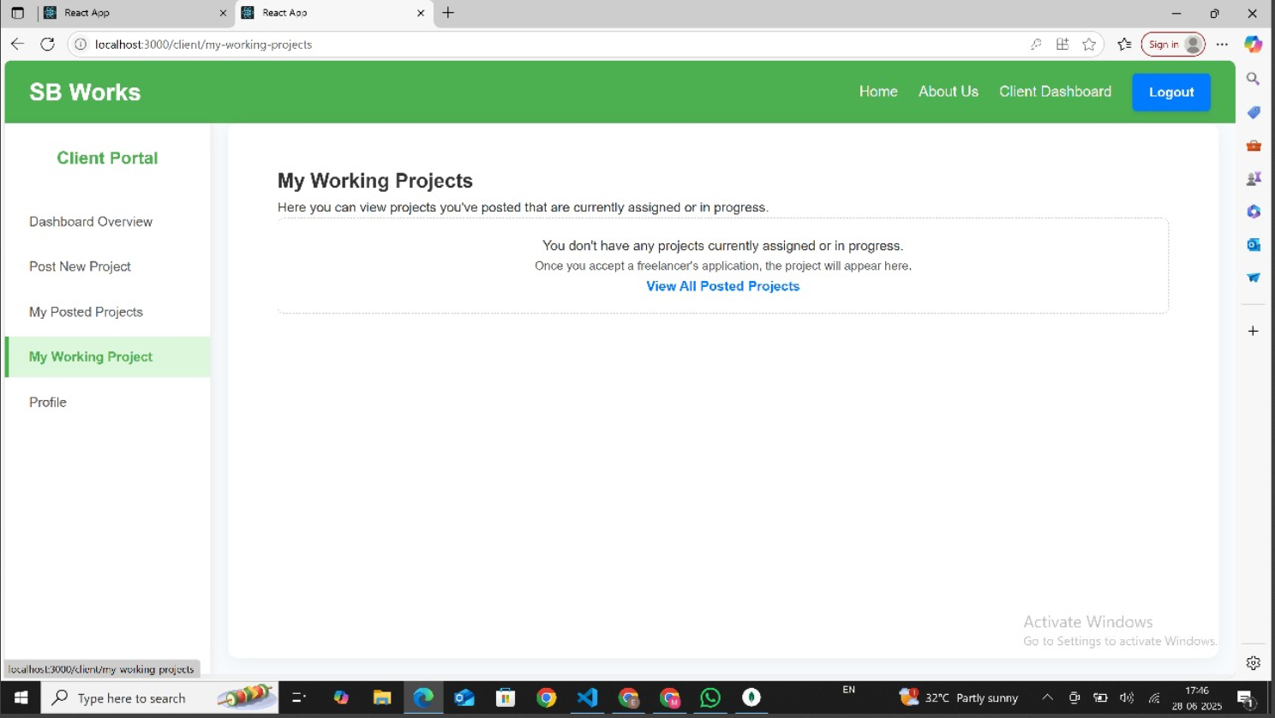

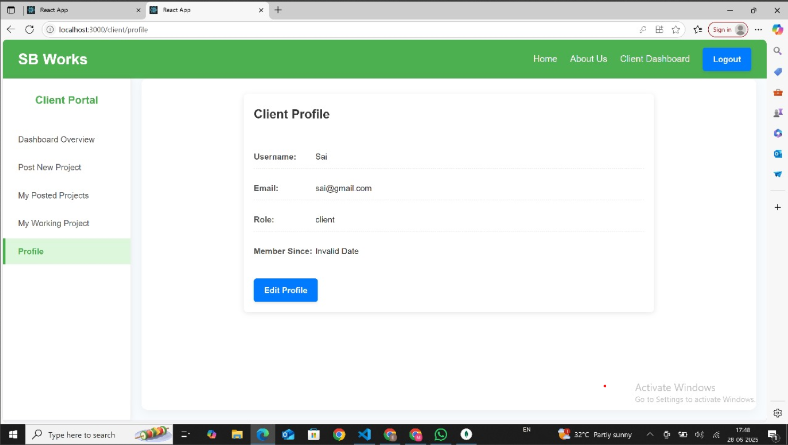

**Freelance Portal:**

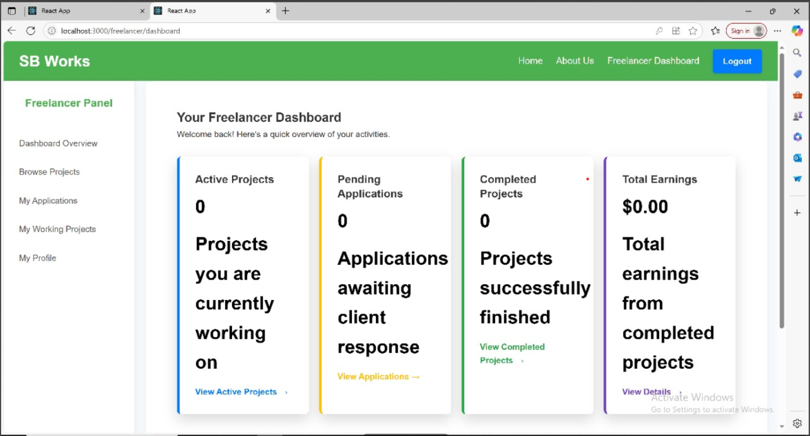

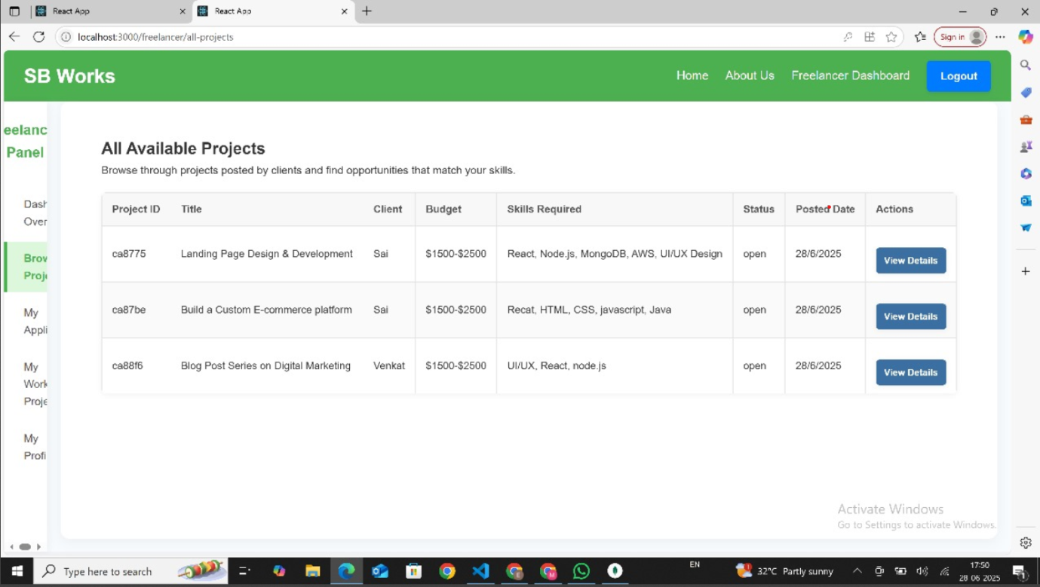

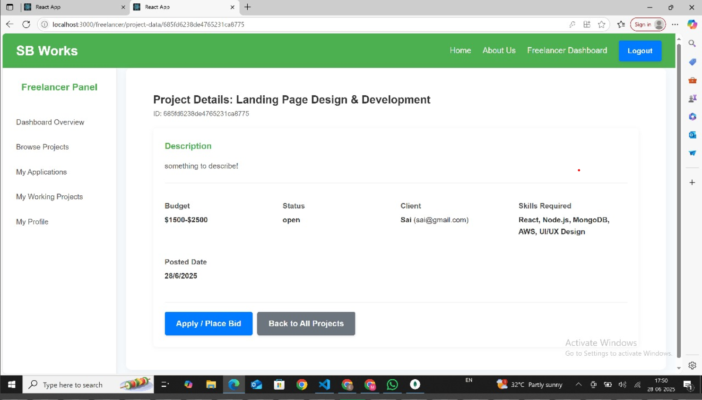

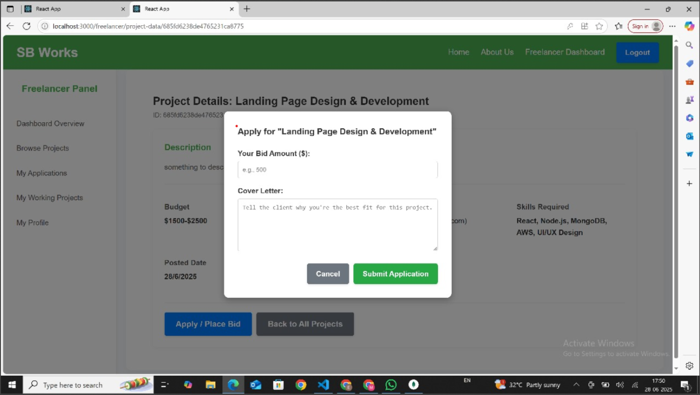

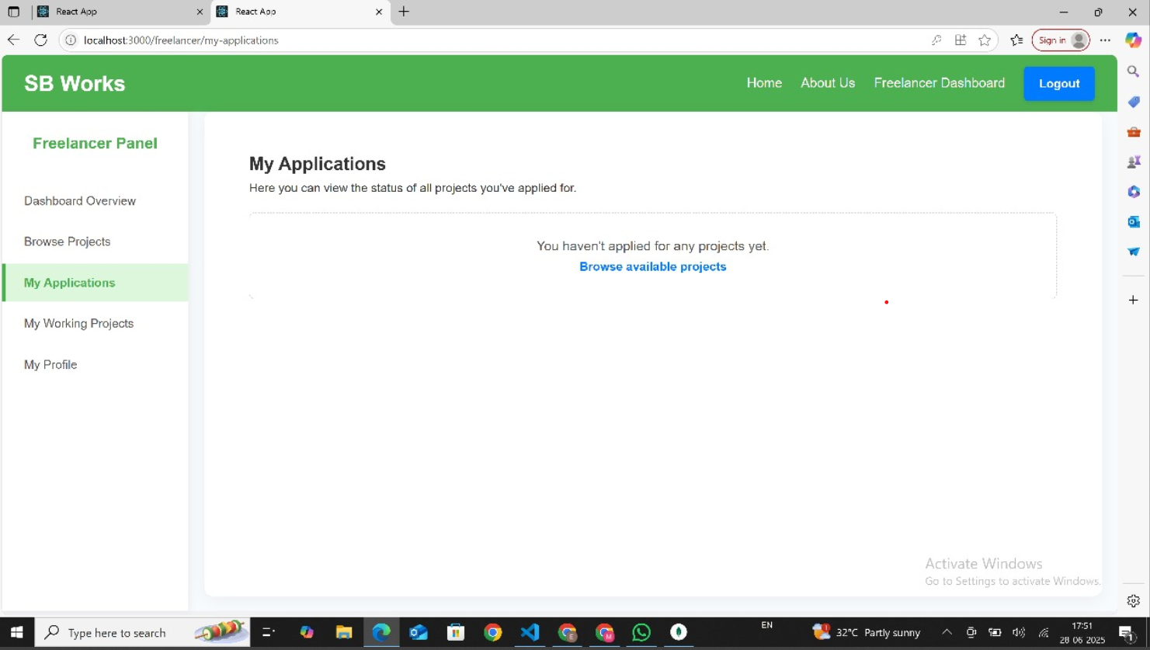

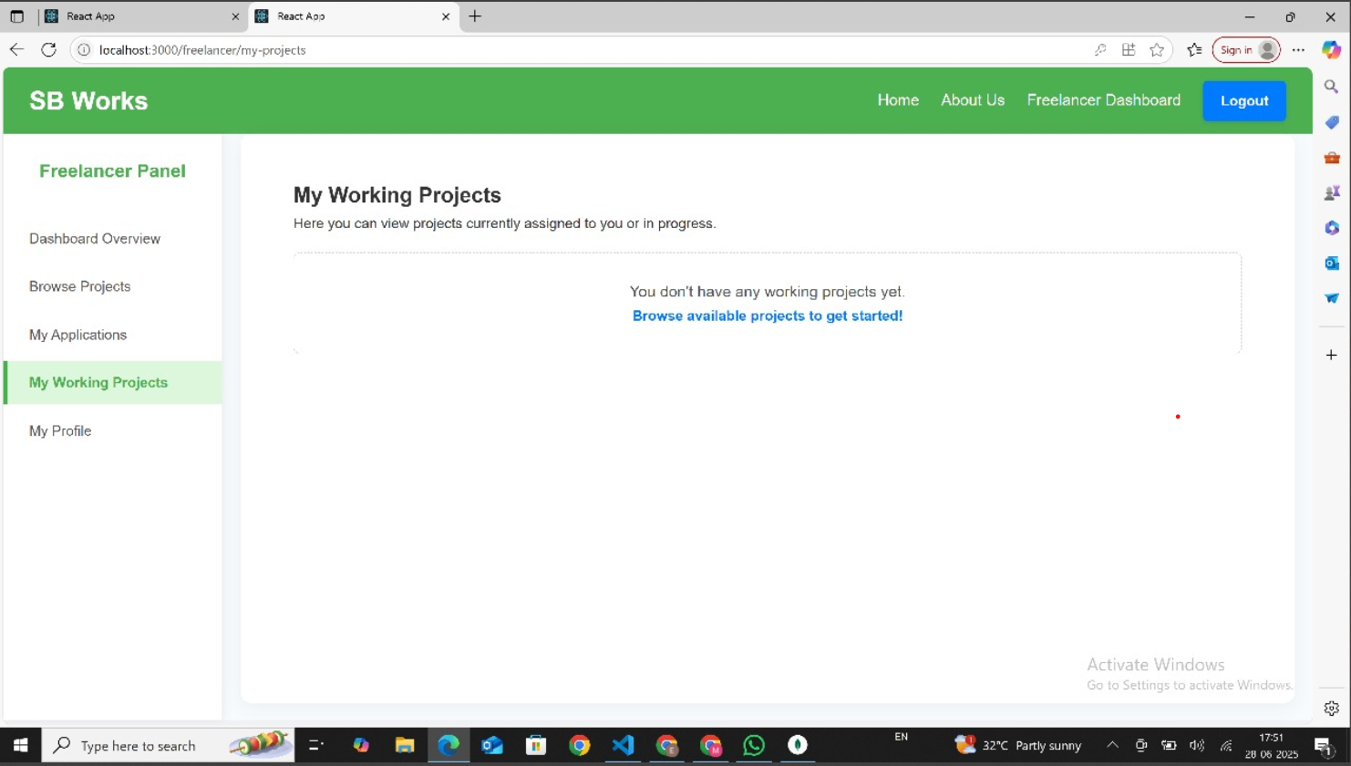

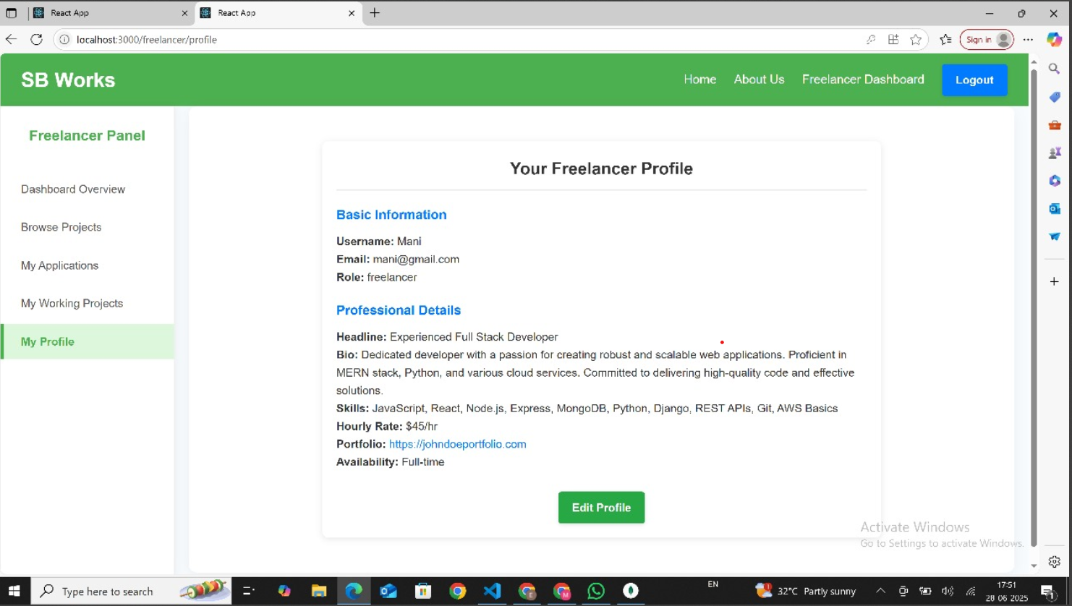

**Admin Portal:**

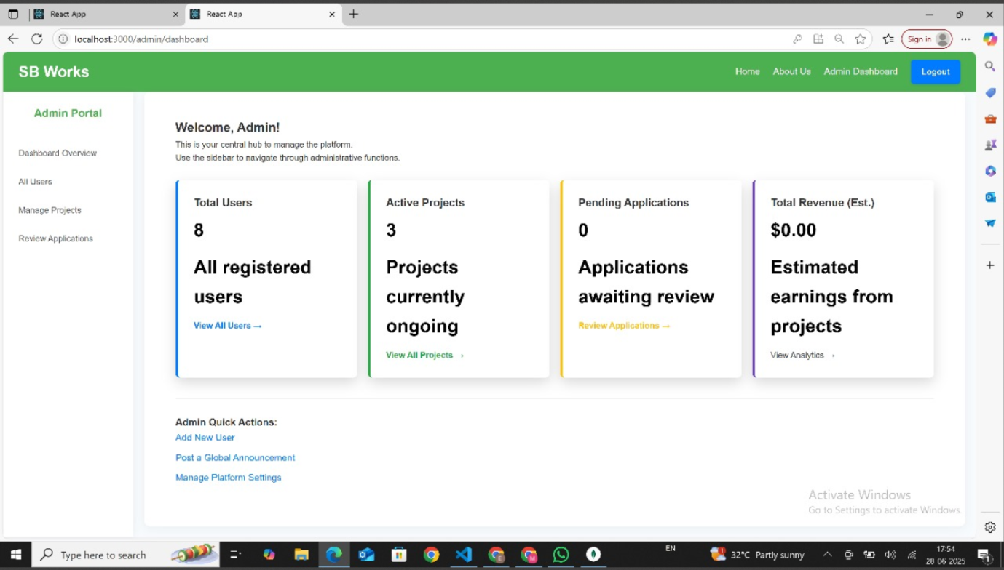

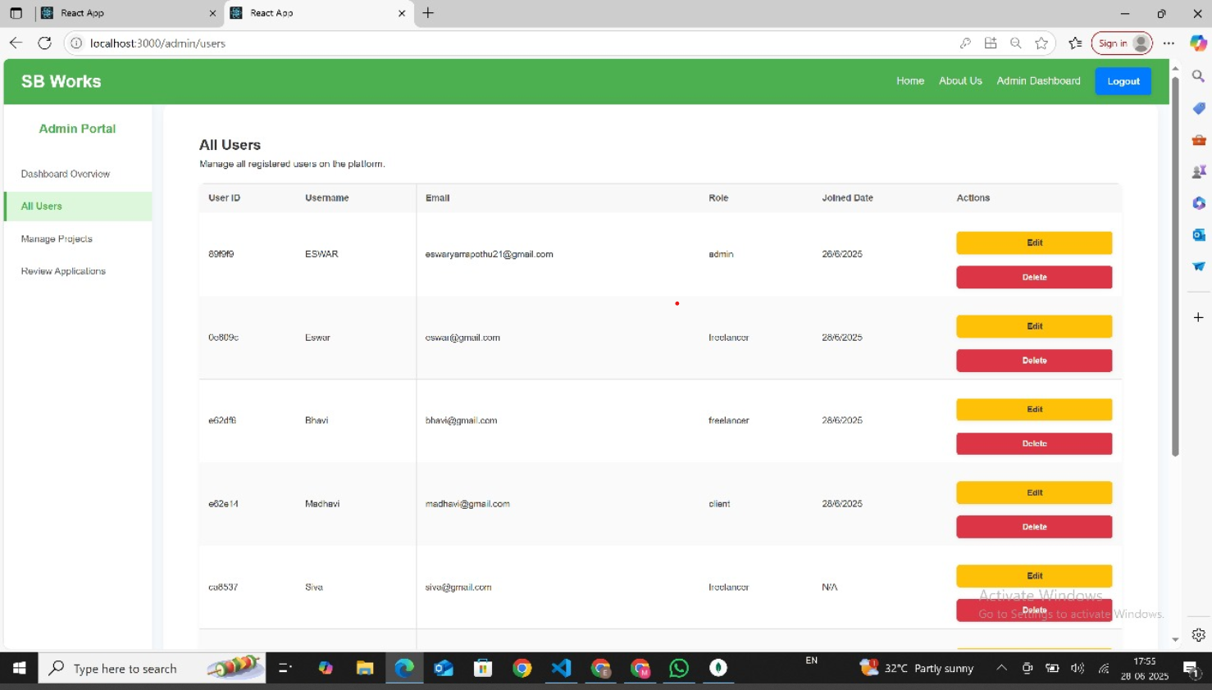

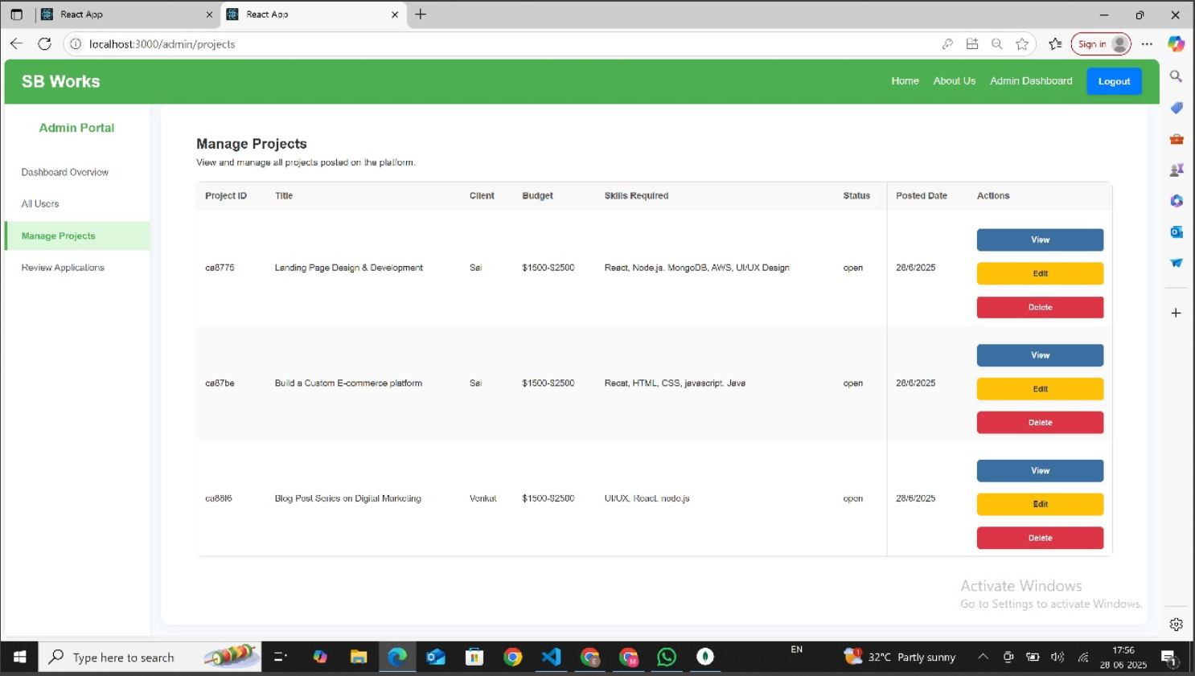

# Conclusion:

FreelanceFinder empowers individuals to take control of their professional journey, one project atatime.Byofferinganintelligent,secure,anduser-friendlyplatform,weaimtounlockthetrue potential of freelance work and connect talent with global opportunities.